**Plant a Prairie Lesson Plan – Photos**

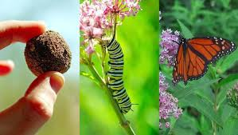

* Image can be shown to students so they can visualize a milkweed seed bomb and what it’s helping   
  to save and attract by growing prairie flowers.

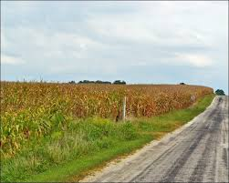

* Photo can be used to help show how prairie grasses can help water run-off, help slow down wind   
  and soil erosion.

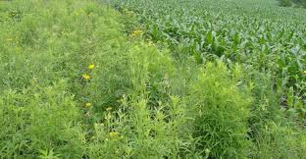

* Photo can be used to show some of the prairie flowers that attract butterflies and other pollinators.